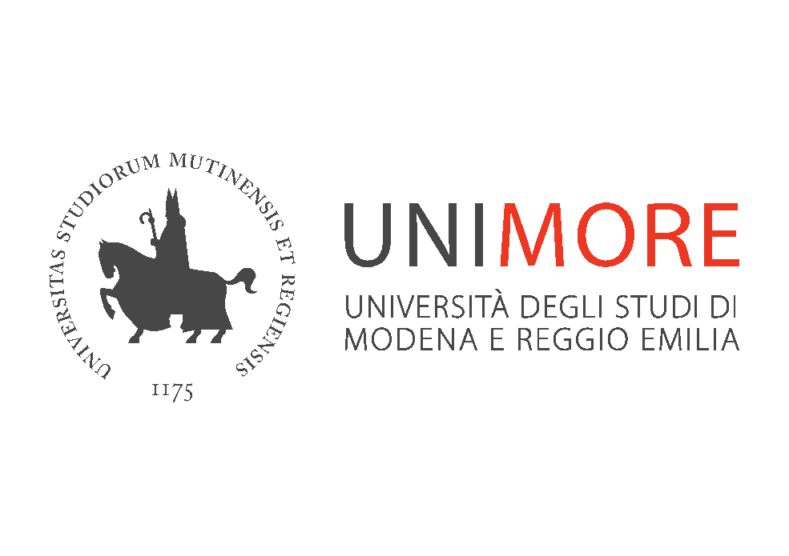

PhD Programme in Law

Business Law
Profs Federico M. Mucciarelli, Alessandro V. Guccione, Alessio Bartolacelli

Department of Law, Unimore
Via san Geminiano, 3 – Modena
Room T

Tuesday, February 3, 2025 – h. 10-13

Corporate Sustainability Law

Implications for Research,
Teaching and Dissemination
_____________

Prof. Beate Kristine Sjåfjell

University of Oslo & College of Europe, Bruges

Seminar opening
Prof. Maria Cecilia Fregni, Unimore
Unimore PhD Programme in Law - Coordinator

Introduction
Prof. Federico M Mucciarelli, Unimore

Chair
Prof. Alessio Bartolacelli, Unimore

Info: alessio.bartolacelli@unimore.it

